|  |  |
| --- | --- |
| **Project – External Document** |  |
| COMP6681001  Web Programming (BB08) |
| Odd Semester Year 2022/2023 |

* Project Title

Movielist

* Introduction

Membuat website movie, dimana pengguna dapat mencari dan mendapatkan informasi mengenai list movie yang paling popular.

* Report / Documentation

Login



Register



Role:

**Guest**

Homepage

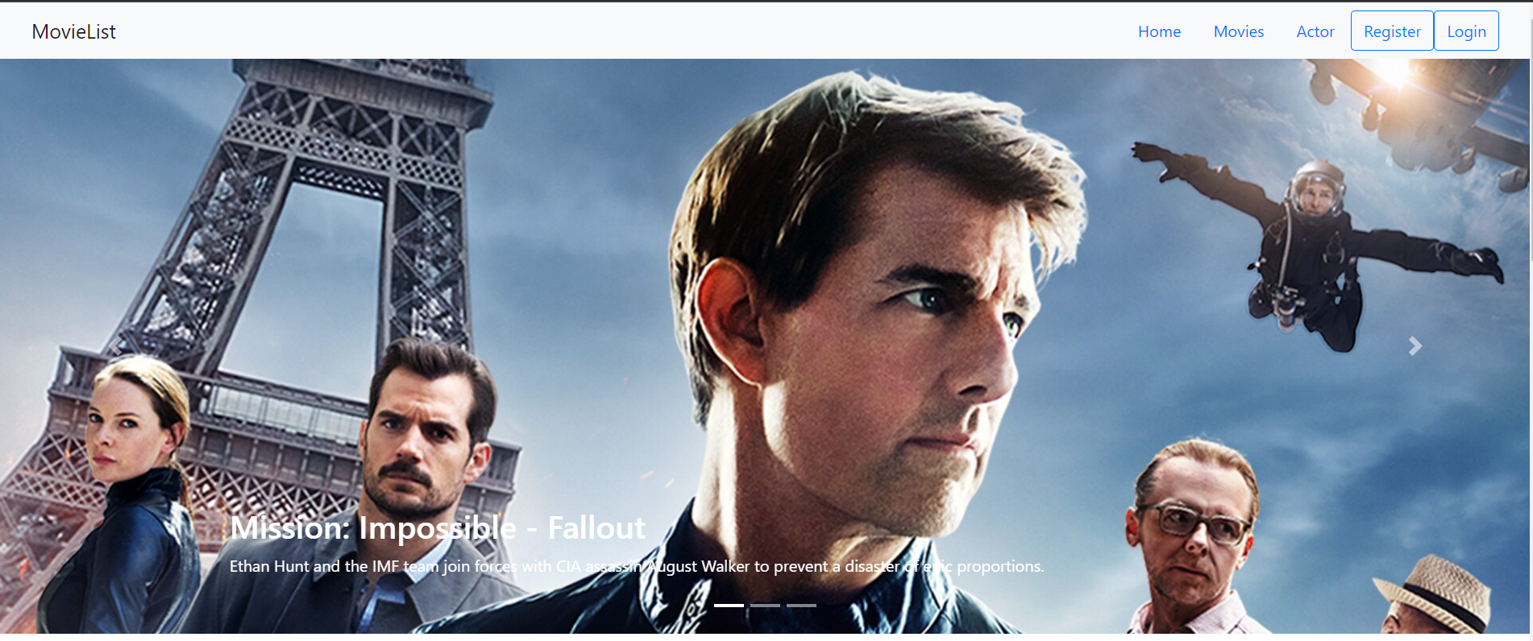

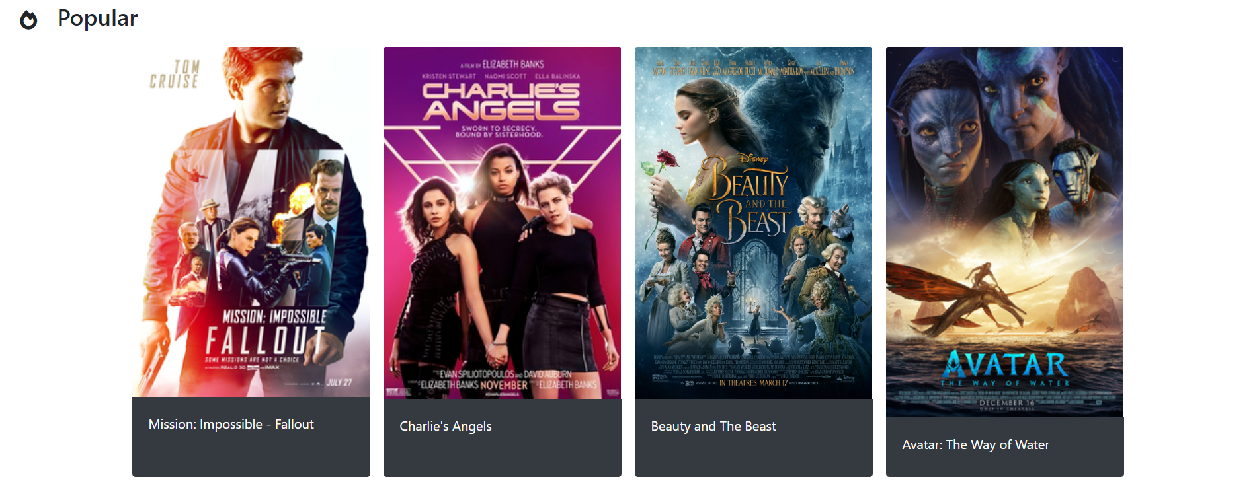

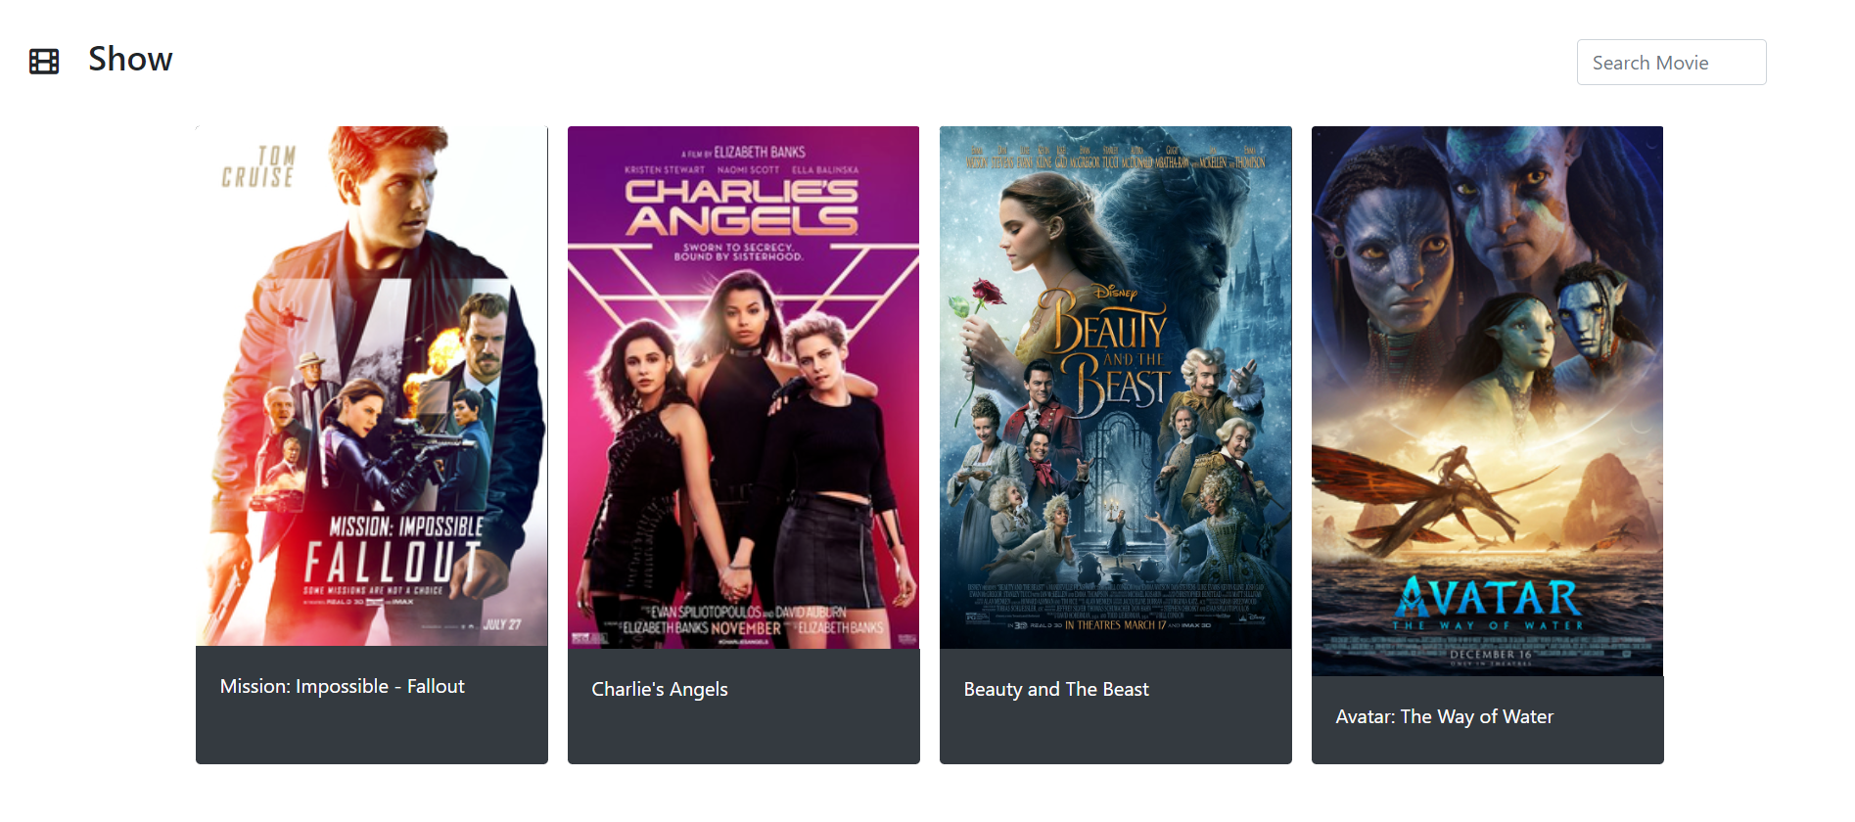

Actor



Actor Detail

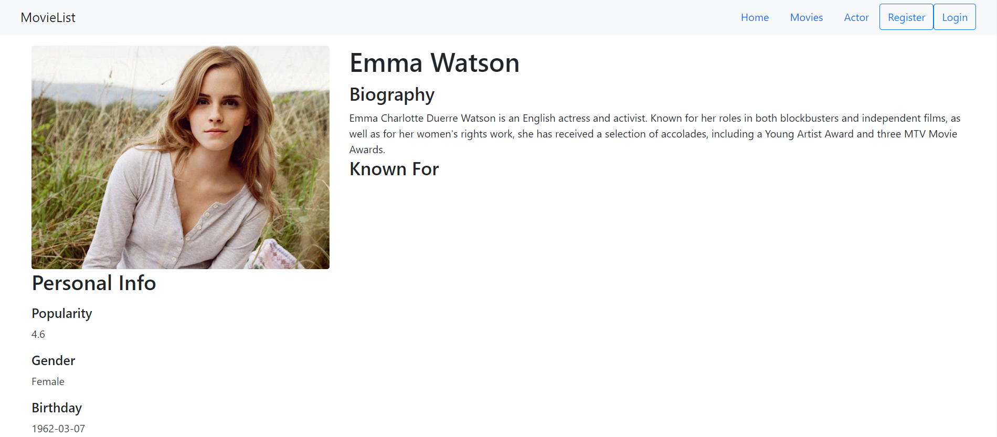

Role guest hanya dapat melihat list movie dan melihat list actor.

**Admin**

Homepage

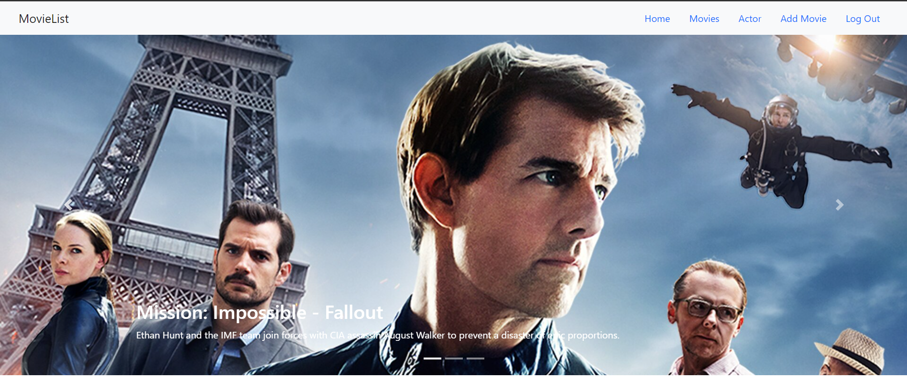

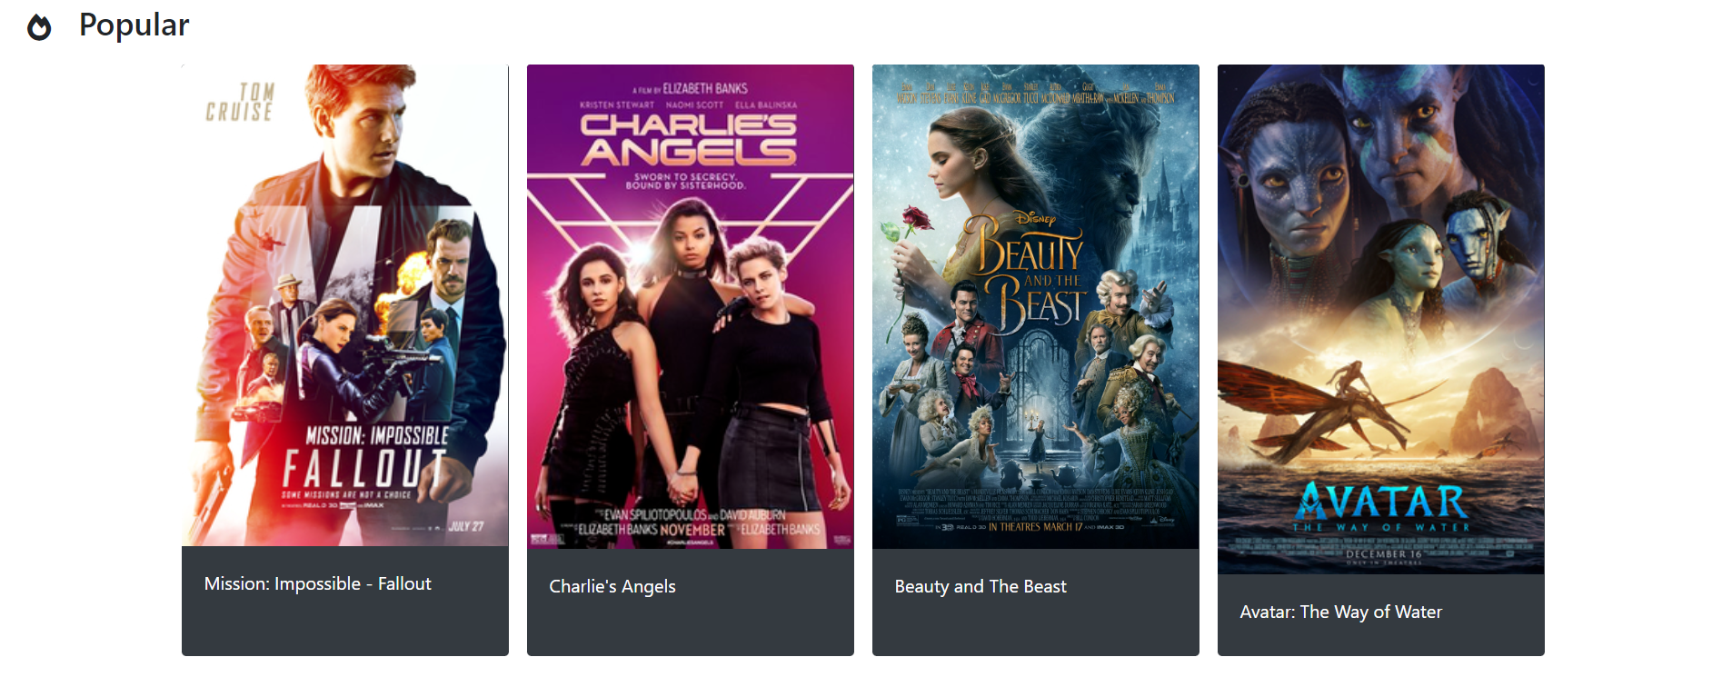

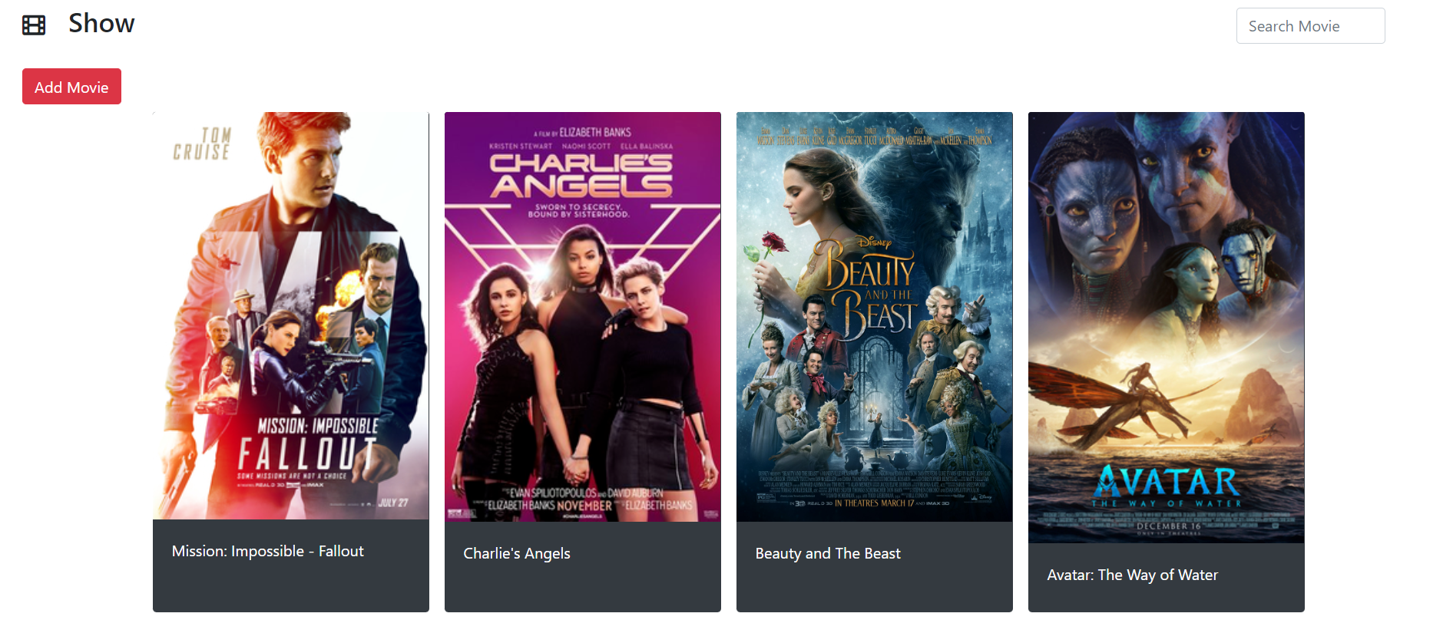

Role admin dapat menambahkan movie dengan menggunakan button add movie.

Add Movie

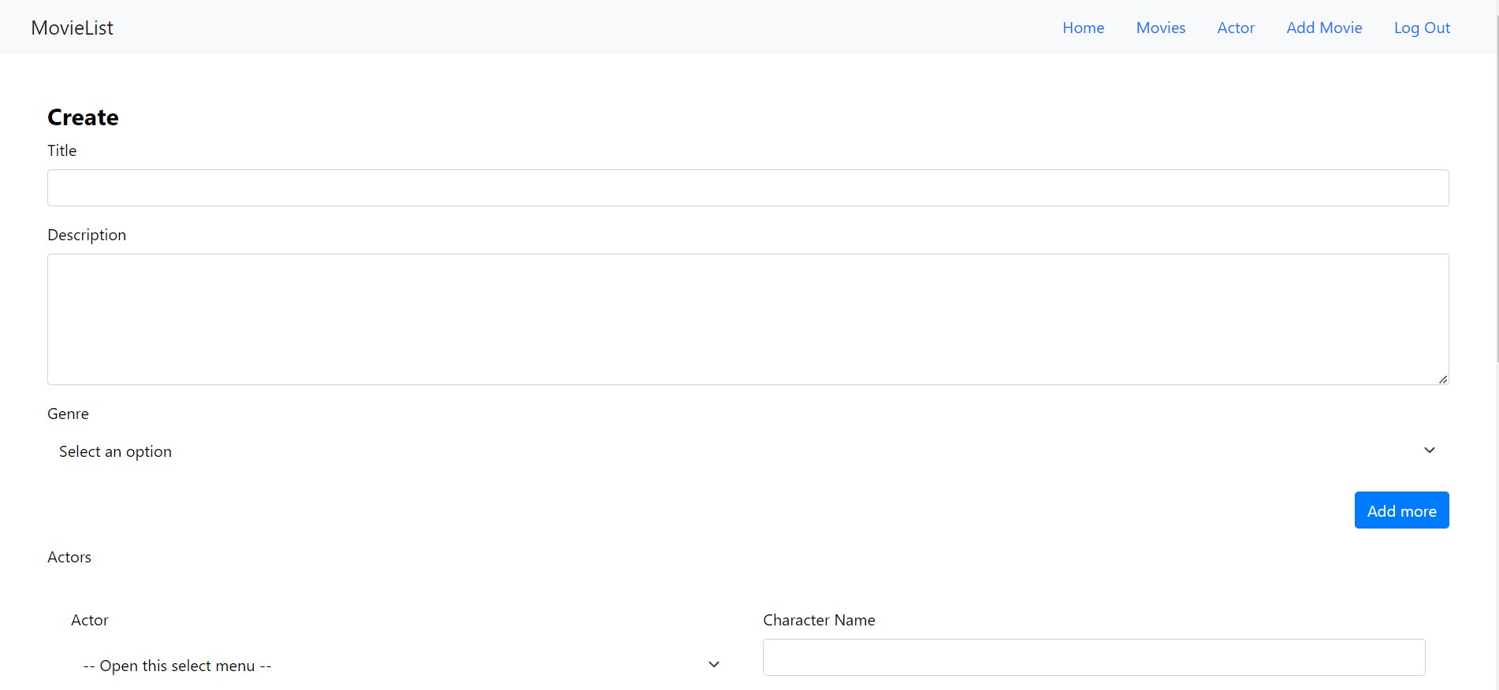

Movie Detail

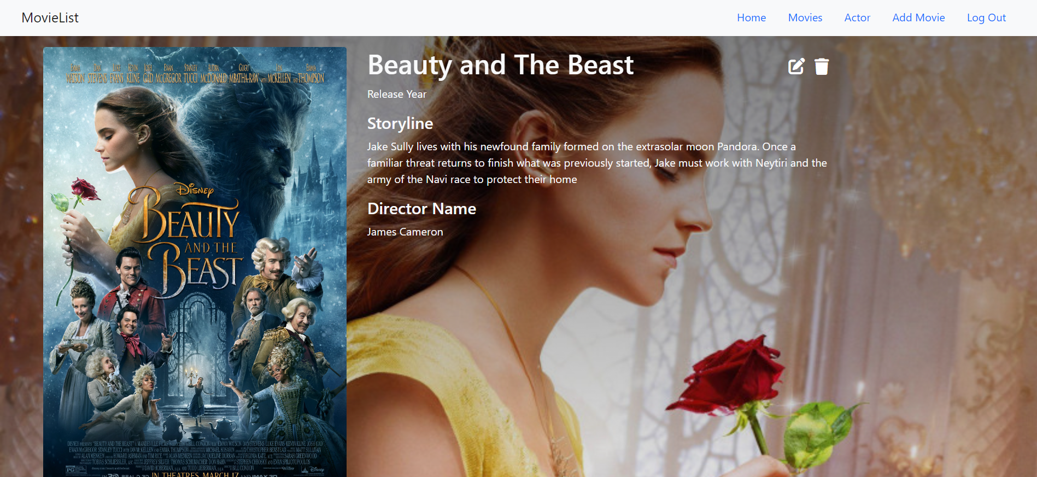

Edit Movie

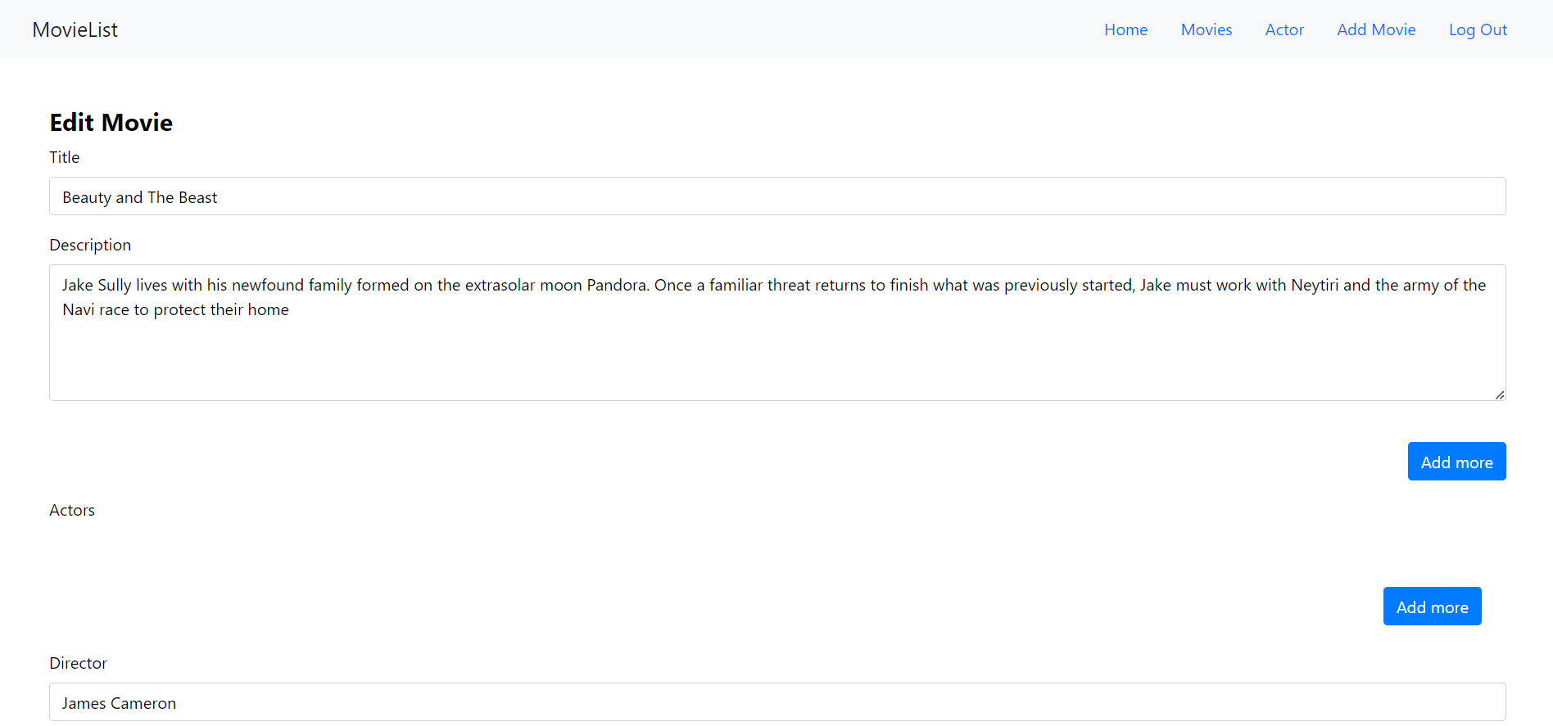

Role admin dapat mengupdate dan menghapus movie pada list.

Actor



Role admin juga melakukan menambahkan actor menggunakan button add actor.

Add Actor

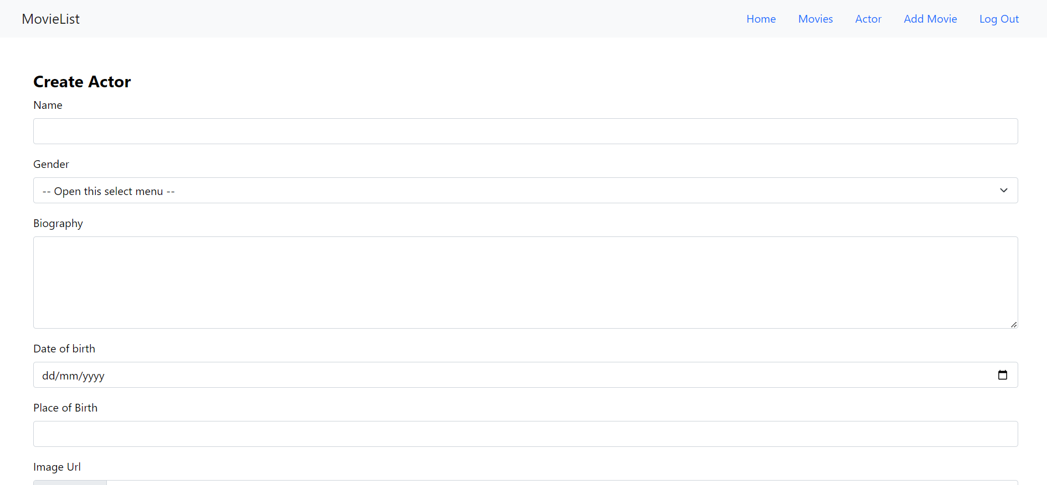

Edit Actor

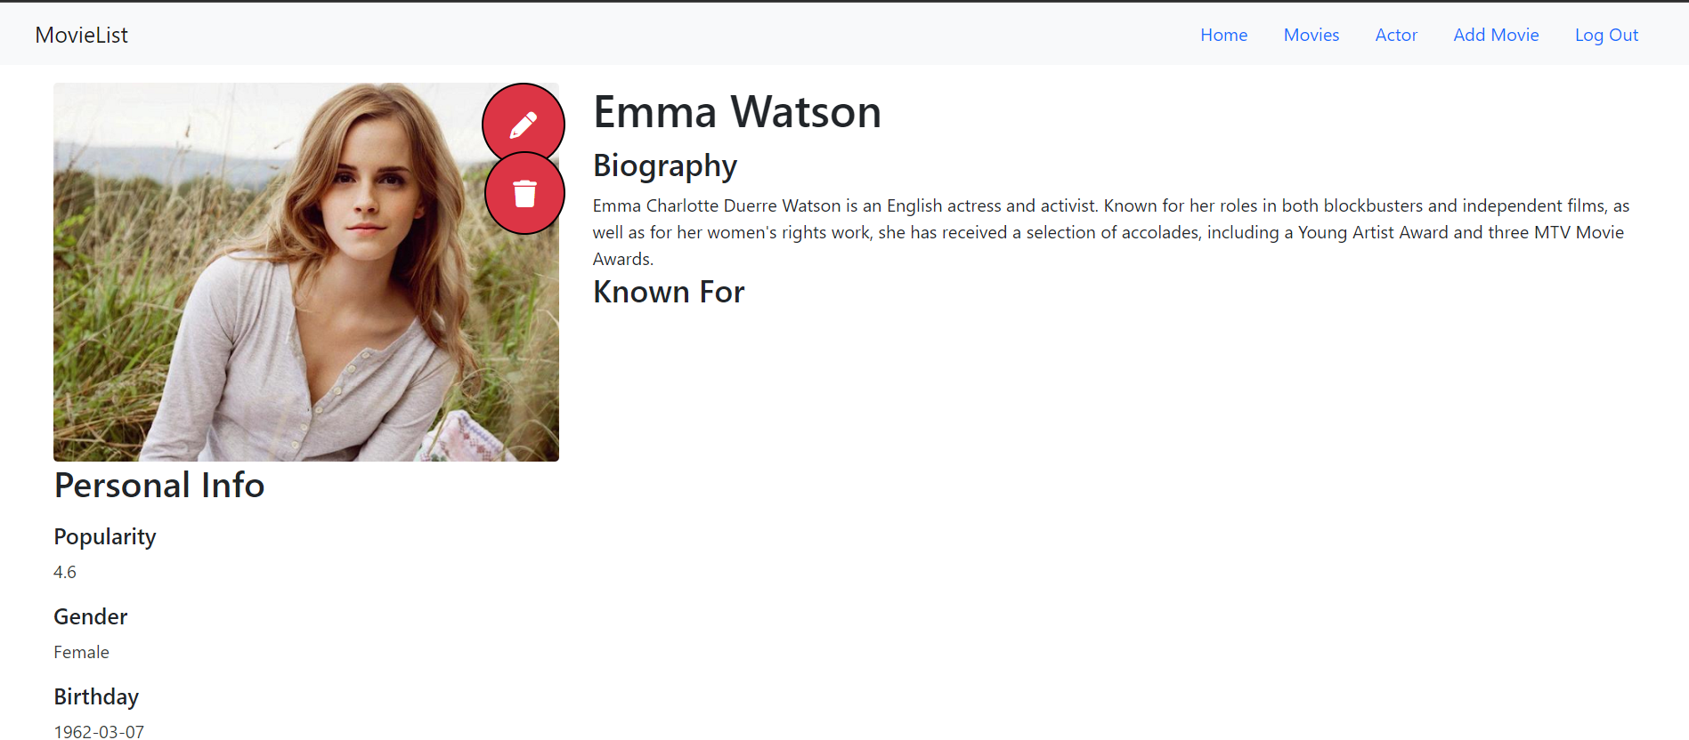

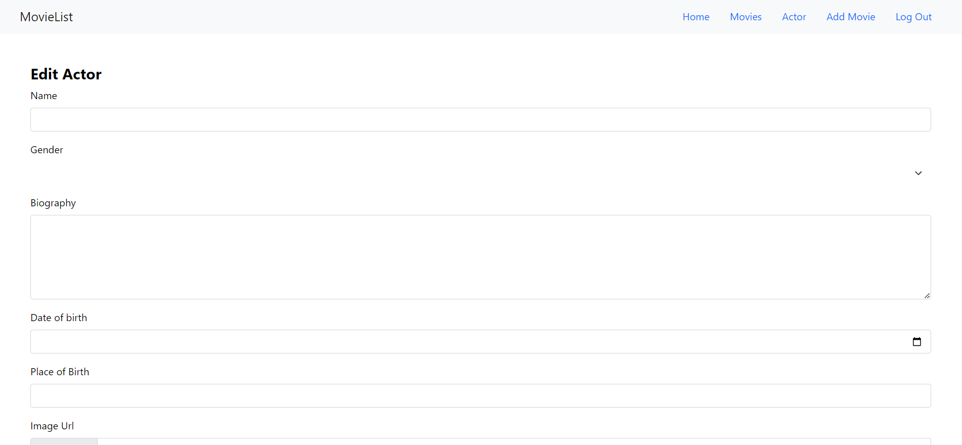

Role admin dapat melakukan update actor.

**User**

Homepage



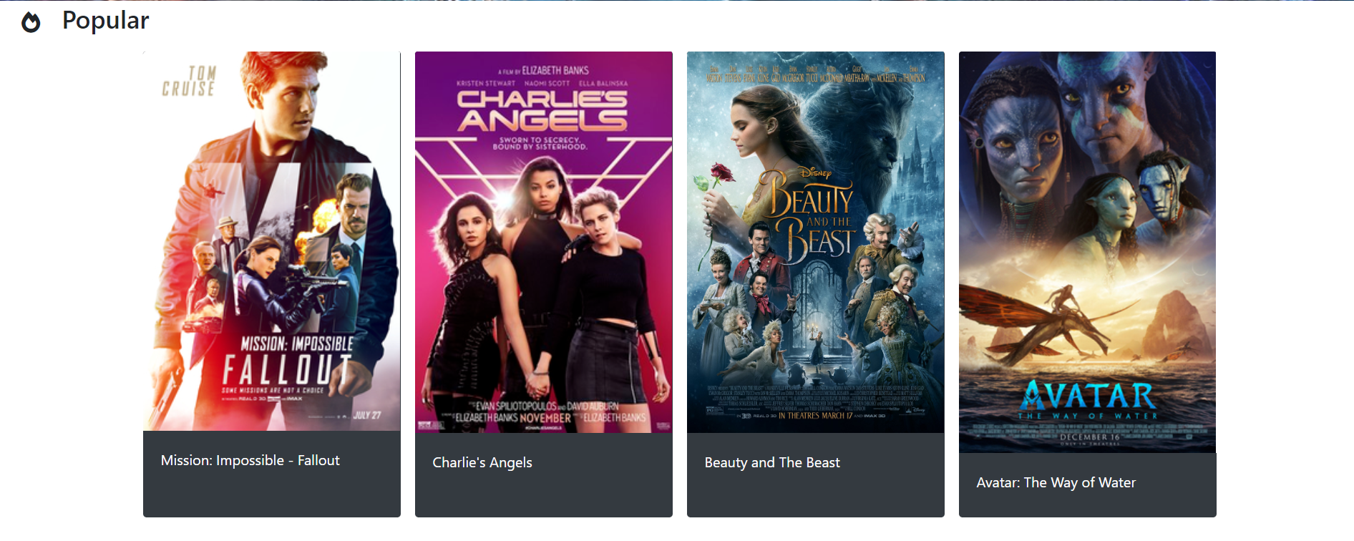

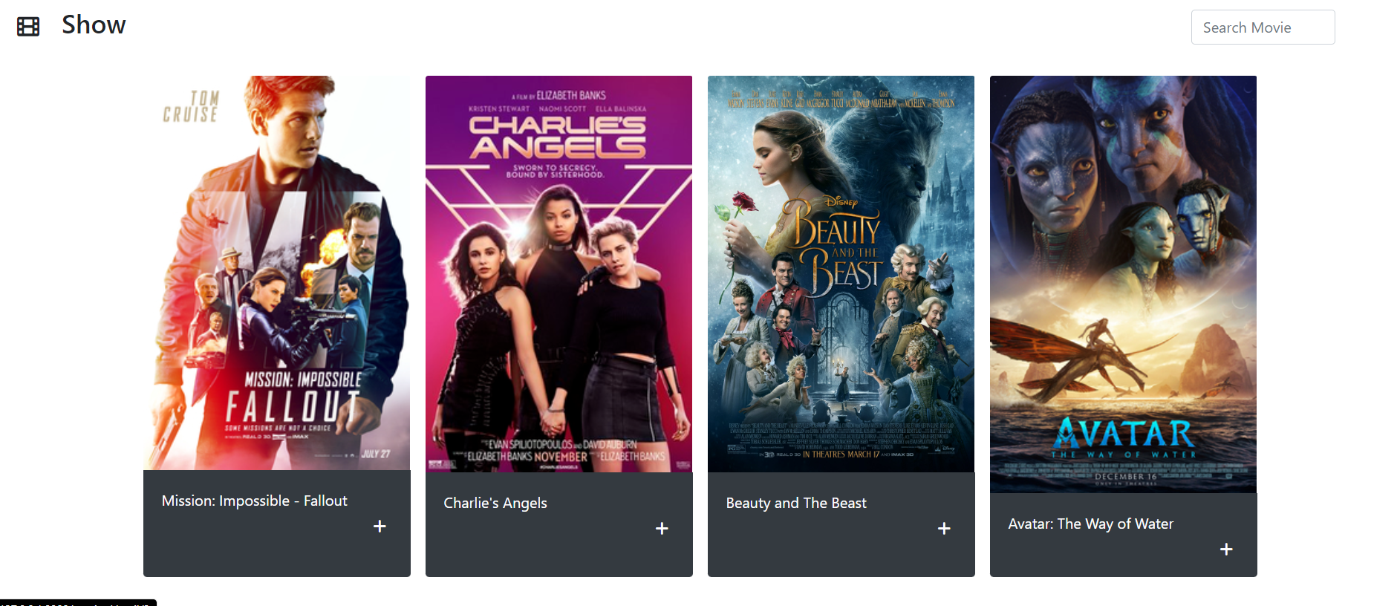

Role member dapat menambahkan movie ke watchlist mereka.

Actor

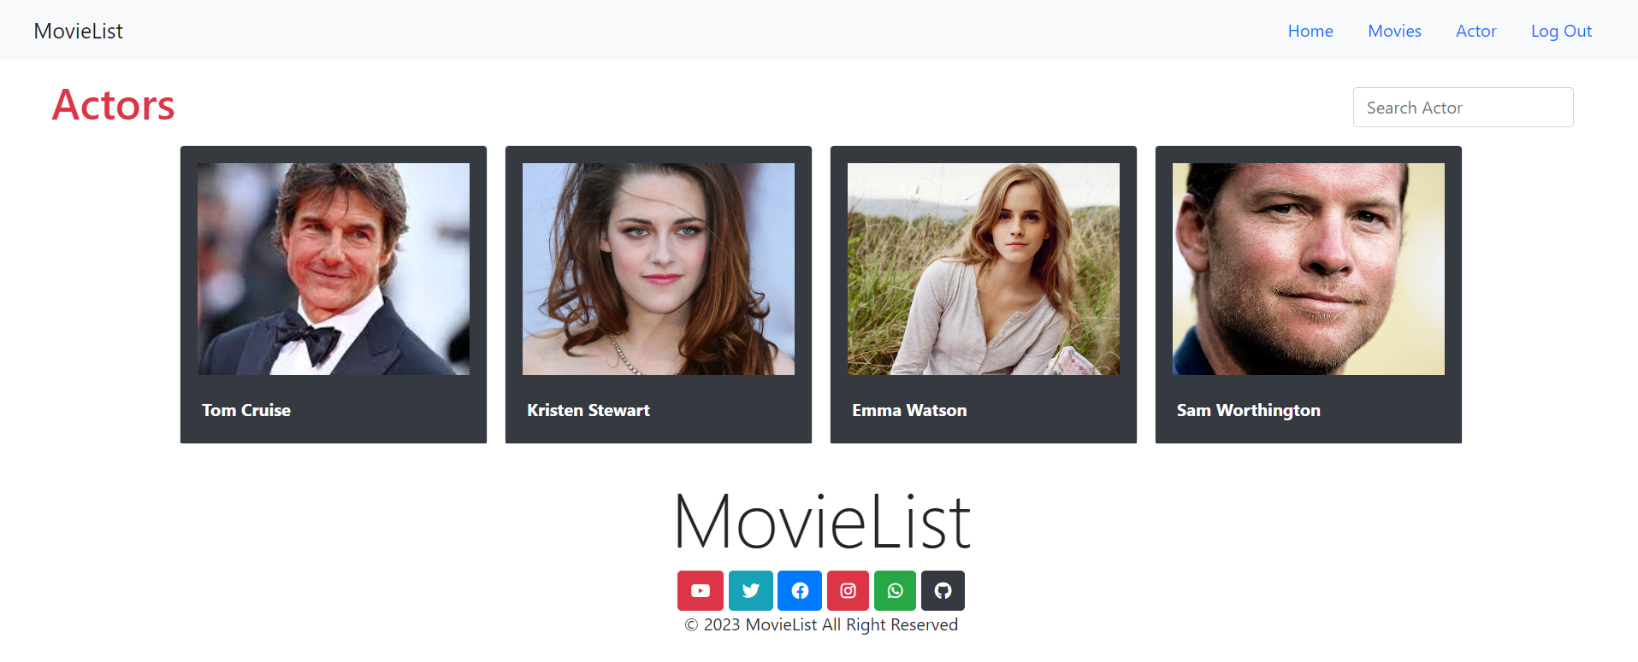

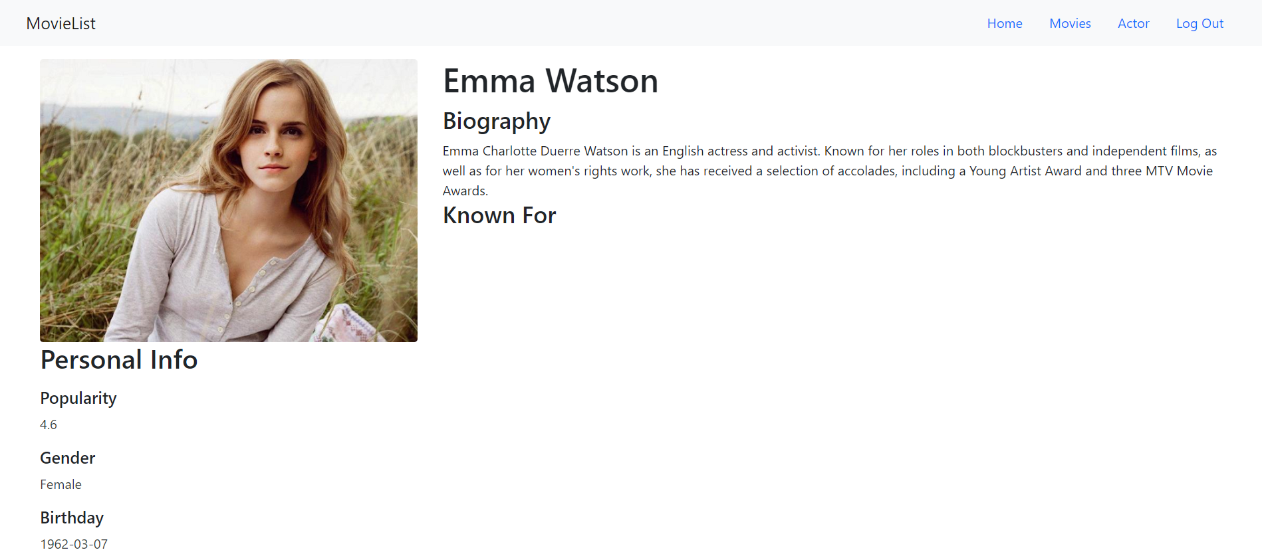

Role member dapat melihat list actor, melakukan pencarian actor yang diinginkan, serta melihat actor detail.

* Reference

Movie

* <https://upload.wikimedia.org/wikipedia/en/f/ff/MI_%E2%80%93_Fallout.jpg>
* <https://upload.wikimedia.org/wikipedia/en/2/2a/Charlie%27s_Angels_%28Official_2019_Film_Poster%29.png>
* <https://m.media-amazon.com/images/I/91p8sSMXpkL.jpg>
* <https://upload.wikimedia.org/wikipedia/en/5/54/Avatar_The_Way_of_Water_poster.jpg>
* [https://ic.c4assets.com/brands/mission-impossible-fallout/c7be71e7-9968-4b38-8f01-c64a70bf9480.jpg?interpolation=progressive-bicubic&output-format=jpeg&output-quality=90{&resize}](https://ic.c4assets.com/brands/mission-impossible-fallout/c7be71e7-9968-4b38-8f01-c64a70bf9480.jpg?interpolation=progressive-bicubic&output-format=jpeg&output-quality=90%7b&resize%7d)
* <https://mmc.tirto.id/image/2019/11/15/film-charlies-angels--1_ratio-16x9.jpg>
* <https://files.oyebesmartest.com/uploads/preview/scrape-wp2345240cl63efzp.jpeg>
* <https://w0.peakpx.com/wallpaper/965/851/HD-wallpaper-avatar-2-2018-poster-fantasy-movie-avatar-2-navi-blue.jpg>

Actor

* <https://upload.wikimedia.org/wikipedia/commons/thumb/6/6c/Sam_Worthington_2013.jpg/640px-Sam_Worthington_2013.jpg>
* <https://catracalivre.com.br/wp-content/uploads/2016/01/kristen_stewart.jpg>
* <https://pict.sindonews.net/dyn/850/pena/news/2021/02/27/187/348564/aktris-emma-watson-pensiun-dari-dunia-akting-semoga-tidak-bte.png>
* <https://monitorindonesia.com/wp-content/uploads/2022/05/Tom-Cruise-saat-menghadiri-Festival-Film-Cannes.png>
* Group Member
* 2440027511 – Sarah Safitri
* 2440046990 – Diva Angelika Mulia